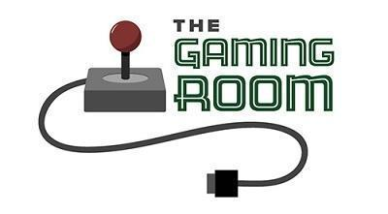

Draw It or Lose It

CS 230 Project Software Design Template
Version 1.0

Table of Contents

CS 230 Project Software Design Template 1
Table of Contents 2
Document Revision History 2
Executive Summary 3
Requirements 3
Design Constraints 3
System Architecture View 3
Domain Model 3
Evaluation 4
Recommendations 5

Document Revision History

Version | Date | Author | Comments
1.0 | 05/26/24 | Dominick Marquez | Added information below each header

Instructions
Fill in all bracketed information on page one (the cover page), in the Document Revision History table, and below each header. Under each header, remove the bracketed prompt and write your own paragraph response covering the indicated information.

Executive Summary

This document outlines the software design for a web-based version of "Draw It or Lose It," a multiplayer guessing game currently only available as an Android app. The proposed solution leverages web technologies to create an experience playable on multiple platforms. Real-time gameplay and data storage will be facilitated through a server-client architecture. HTML, CSS, and JavaScript frameworks will be used to build the user interface and ensure smooth interaction with the server. The server will manage game logic, user accounts, and communication between clients.

Requirements

The Gaming Room requires a web-based version of "Draw It or Lose It" that facilitates multiplayer competition. Teams with unique names can be formed with multiple players, and only one game instance can be active at a time (enforced by unique identifiers). To ensure a smooth experience across devices, the game needs to run on web browsers while enabling real-time interaction between teams during gameplay.

Design Constraints
- Network Latency: Minimizing network latency is critical for maintaining a responsive and enjoyable gameplay experience. Techniques like efficient data transfer and real-time communication protocols will be addressed.
- Cross-Platform Compatibility: The web application should adapt to different screen sizes and device capabilities. Responsive design principles and adaptable user interfaces will be employed.
- Security: User authentication, data encryption, and secure communication channels are essential to protect user information and prevent cheating.
Design Constraint Implications: These constraints influence development decisions.
- Real-time updates: Different techniques will be explored to facilitate real-time communication between clients and the server.
- Scalability: The server architecture needs to be scalable to handle multiple concurrent games and players.
- Client-side optimizations: Code optimization and efficient resource management will be crucial for smooth performance across various devices.

System Architecture View

Please note: There is nothing required here for these projects, but this section serves as a reminder that describing the system and subsystem architecture present in the application, including physical components or tiers, may be required for other projects. A logical topology of the communication and storage aspects is also necessary to understand the overall architecture and should be provided.

Domain Model

Object-Oriented Programming (OOP) principles:
Inheritance: The Game, Team, and Player classes inherit from the Entity class. This promotes code reuse and avoids redundancy by placing common attributes and methods in the base class.
Aggregation: The GameService class has an attribute games which is a list of Game objects. This indicates that a GameService instance can hold multiple Game objects.

How OOP principles fulfill the software requirements:
Unique Identifiers: The use of unique identifiers for entities (games, teams, players) through the Entity base class addresses the requirement of having non-repeating names for teams and games.
Multiplayer Functionality: The ability to have multiple Team objects within a Game instance allows for the multiplayer aspect.
Team Management: The Team class with its players attribute (which holds a list of Player objects) represents the ability to manage teams and assign players to them.

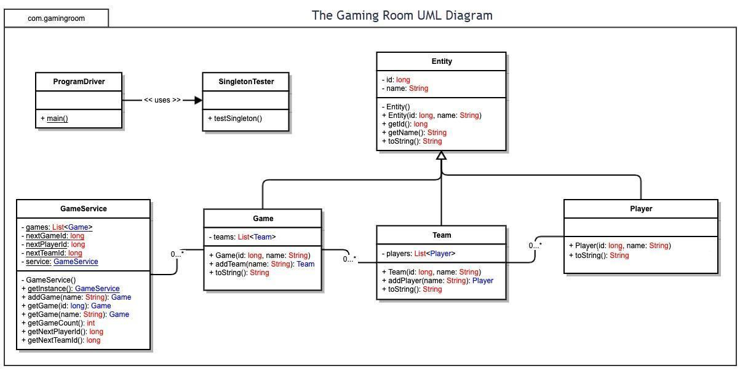

Evaluation

Using your experience to evaluate the characteristics, advantages, and weaknesses of each operating platform (Linux, Mac, and Windows) as well as mobile devices, consider the requirements outlined below and articulate your findings for each. As you complete the table, keep in mind your client’s requirements and look at the situation holistically, as it all has to work together.

In each cell, remove the bracketed prompt and write your own paragraph response covering the indicated information.

Development Requirements | Mac | Linux | Windows | Mobile Devices
Server Side | Characteristics:  -Unix-Based, Stable, and Secure  Advantages:  -Server-Based Deployment (Apache, Nginx)  Disadvantages:  -Only Free and Open Source when running on Mac Server.  -May require additional configuration  -Higher hardware costs | Characteristics:  -Unix-Based, Stable, and Secure  Advantages:  -Server-Based Deployment (Apache, Nginx)  - Free and Open Source  Disadvantages:  -less software support for linux  -fewer pre-configured options  -smaller talent pool | Characteristics:  Advantages:  -Server-Based Deployment (IIS)  -large talent pool  -software compatibility  Disadvantages:  -Window Server Licensing costs apply  -potential for misconfigurations  -higher resource footprint compared to linux  -limited ecosystem | Characteristics:  Advantages:  -native mobile apps have full access to device features  -optimized features  -offline functionality  Disadvantages:  -app store and google play fees
Client Side | Cost:  -save on cost since there is no need for separate cosebases  Time:  -make time to test safari browser  Expertise:  -macOS  -Safari Browser  -Swift Programming language | Cost:  -save on cost by using languages that are compatible across most browsers  Time:  -make time to test Chrome or Firefox  Expertise:  -Familiar with Linux  -Package Managers | Cost:  -save on cost by using languages that are compatible across most browsers  Time:  -make time to test popular browsers  Expertise:  -Familiar with Edge browser | Cost:  -increased cost  -separate code bases or frameworks  -device testing  Time:  -increased development time  -learning curve  -device testing time  Expertise:  -Native development tools  -mobile web frameworks  -mobile testing
Development Tools | IDEs:  -Xcode  Languages:  -Swift  -HTML5  -CSS3  -JavaScript | IDEs:  -Visual Studio Code  Languages:  -HTML5  -CSS3  -JavaScript | IDEs:  -Visual Studio  -VS Code  -Atom  Languages:  -HTML5  -CSS3  -JavaScript | IDEs:  -Visual Studio code  Languages:  -HTML5  -CSS3  -JavaScript  -iOS: Swift  -Android: Java or Kotlin  Tools:  -Emulators  -Simulators  -Mobile Browser Developer Tools

Recommendations

Analyze the characteristics of and techniques specific to various systems architectures and make a recommendation to The Gaming Room. Specifically, address the following:

- Operating Platform: Cloud-based platform like Google Cloud Platform (GCP) or Amazon Web Services (AWS). These platforms offer scalability, cost-effectiveness, and most importantly cross-platform compatibility.

- Operating Systems Architectures: Both GCP and AWS offer virtual machines (VMs). The VM can either be linux or windows bases. VMs can be configured with different specifications like CPU cores, memory (RAM), and storage capacity. The Gaming Room can easily scale the VR resources based on the game’s demands.

- Storage Management: GCP and AWS offer cloud storage for hosting the game’s image library and other application data. For improved performance a Content Delivery Network (CDN) can be integrated.

- Memory Management: Employ techniques like paging and swapping to manage memory allocation across VMs. VMs can handle virtualization and memory allocation. Application should be designed with memory efficiency in mind and should use profiling tools to identify and fix memory leaks.

- Distributed Systems and Networks: To enable cross-platform communication, we can leverage a distributed software architecture with a central server and a network infrastructure. Client applications will connect to the central server. The central server will act as the central hub for communication and game logic. The distributed database will store user information, game data, and session details. The cloud platform (GCP or AWS) will provide a secure network connection between clients, the game server, and the database.

- Security: Cloud Platforms will come with security features such as data encryption, authentication and authorization, network security, regular security updates. By combining the security features of the cloud platform with secure coding practices and ongoing security measures within the application, The Gaming Room can create a secure environment for Draw It or Lose It users across various platforms.

